

**Lab Report**

**Course Code: CSE-114**

**Course Title: Problem Solving Lab**

**Topic: Array**

**Submitted to: Dr. Sheak Rashed Haider Noori**

**Professor & Associate Head,**

**Department of CSE,**

**Daffodil International University, Ashulia, Dhaka.**

**Submitted by : Ashraful Islam Redoy**

**ID: 232-15-178**

**Department of CSE ,**

**Daffodil International University, Ashulia, Dhaka.**

**Problem No: 1**

**Problem Name:** Write a c program, declare an array with a size of 5. Store 10, 20, 30, 40 and 50 in it and print them as output.

**Source Code:**

#include<stdio.h>

int main()

{

int air[5]= {10,20,30,40,50};

int r;

for(r=0; r<5; r++)

{

printf("%d",air[r]);

if(r==4)

{

break;

}

printf(" ");

}

return 0;

}

**Screenshot of output:**

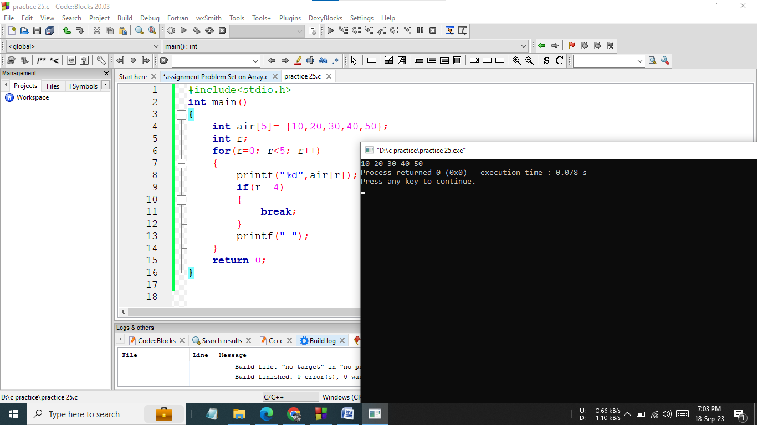

**Hand Written** **Code**:

**Problem No: 2**

**Problem Name:** Write a C program to take 4 size array and array elements from the user ,and print them.

**Source Code:**

#include<stdio.h>

int main()

{

int a[4],i;

for(i=0; i<4; i++)

{

scanf("%d",&a[i]);

}

for(i=0; i<4; i++)

{

printf("%d\n",a[i]);

}

return 0;

}

**Screenshot of output:**

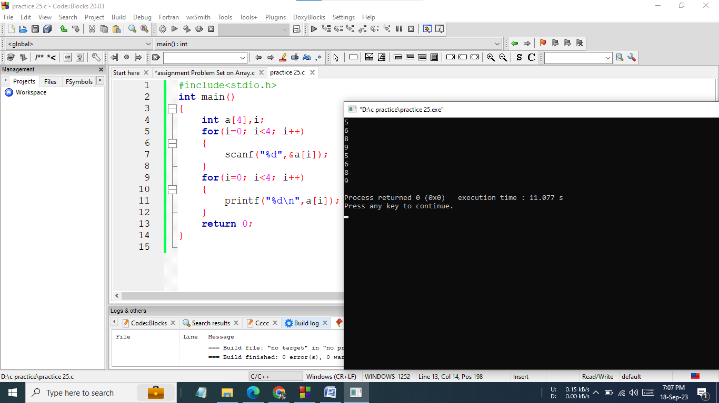

**Hand Written** **Code**:

**Problem No: 3**

**Problem Name:** Take a n size array and take the array element from the user and print them.

**Source Code:**

#include<stdio.h>

int main()

{

int i,n;

printf("Array size : ");

scanf("%d",&n);

int air[n];

for(i=0; i<n; i++)

{

scanf("%d",&air[i]);

}

for(i=0; i<n; i++)

{

printf("%d\n",air[i]);

}

return 0;

}

**Screenshot of output:**

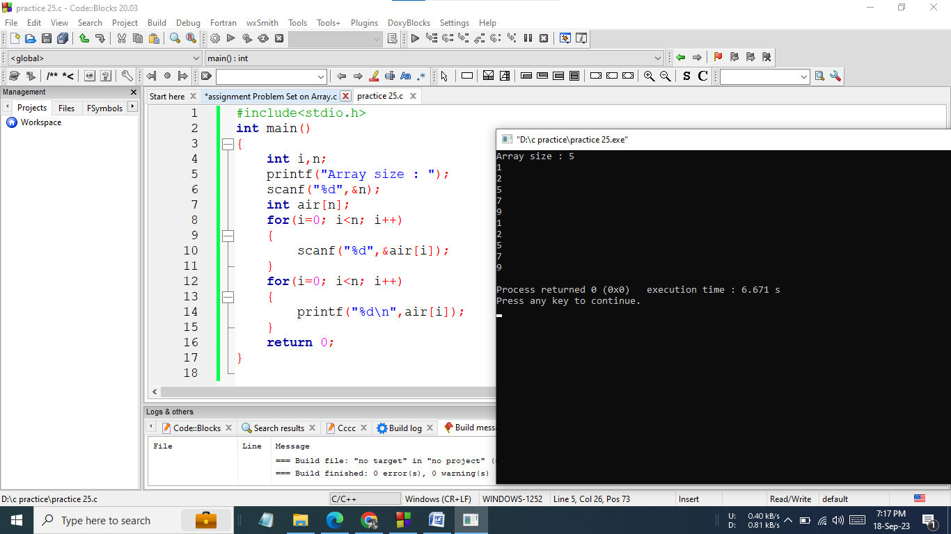

**Hand Written** **Code**:

**Problem No: 4**

**Problem Name:** Take a n size array and take the array element from the user and print them.

**Source Code:**

#include<stdio.h>

int main()

{

int i,n;

printf("Enter arry size : ");

scanf("%d",&n);

int air[n];

for(i=0; i<n; i++)

{

scanf("%d",&air[i]);

}

printf("your elements : ");

for(i=0; i<n; i++)

printf("%d ",air[i]);

printf("\n");

for(i=0; i<n; i++)

{

printf("a[%d]=%d\n",i,air[i]);

}

return 0;

}

**Screenshot of output:**

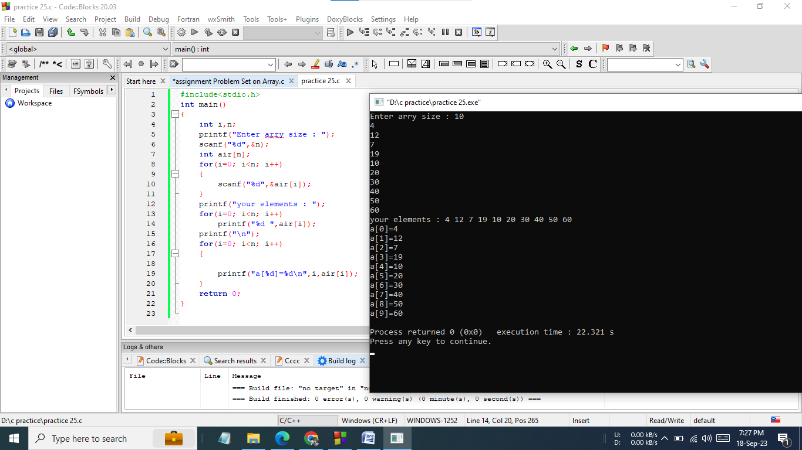

**Hand Written** **Code**:

**Problem No: 5**

**Problem Name:** Write a C program to take 7 values from the user in an array. Use a loop to input those values from the user. As output, print those values.

**Source Code:**

#include<stdio.h>

int main()

{

int air[7];

for(int i=0; i<7; i++)

{

scanf("%d",&air[i]);

}

printf("Inputted values:\n");

for(int j=0; j<7; j++)

{

printf("%d\n",air[j]);

}

return 0;

}

**Screenshot of output:**

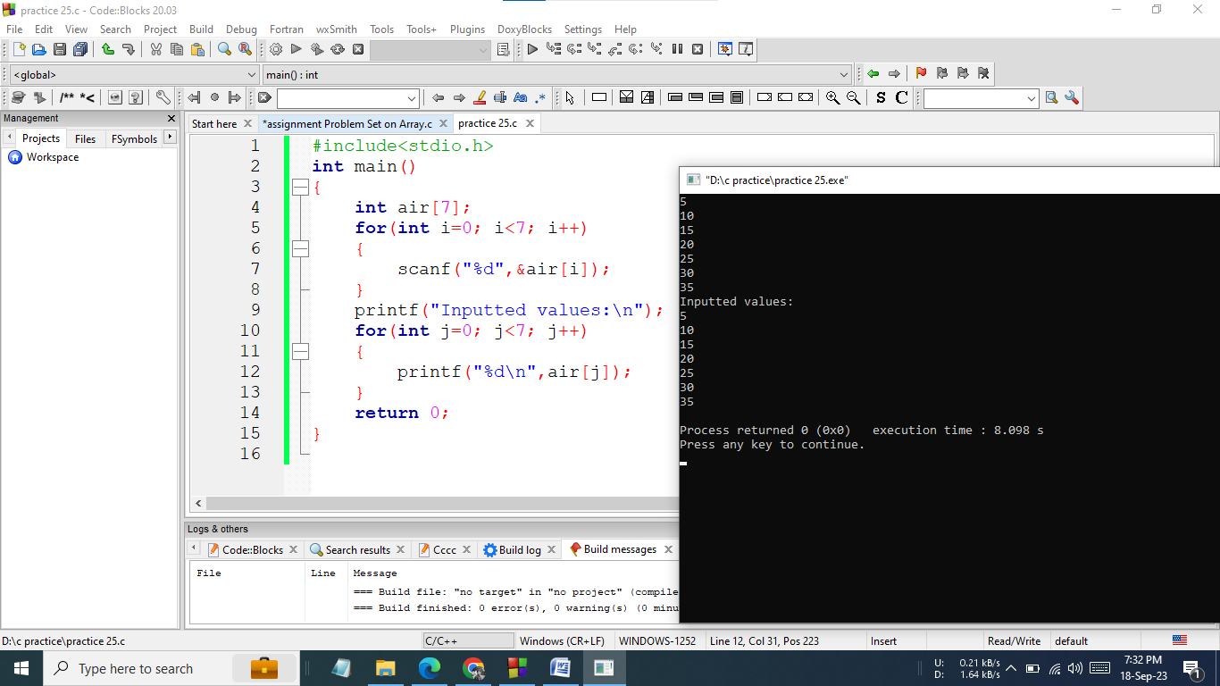

**Hand Written** **Code**:

**Problem No: 6**

**Problem Name:** Take a N size array from the user and array input take from the user and print it in the reverse way.

**Source Code:**

#include<stdio.h>

int main()

{

int n;

printf("size : ");

scanf("%d",&n);

int air[n];

for(int i=0; i<n; i++)

{

scanf("%d",&air[i]);

}

for(int i=n-1; i>=0; i--)

{

printf("%d\n",air[i]);

}

return 0;

}

**Screenshot of output:**

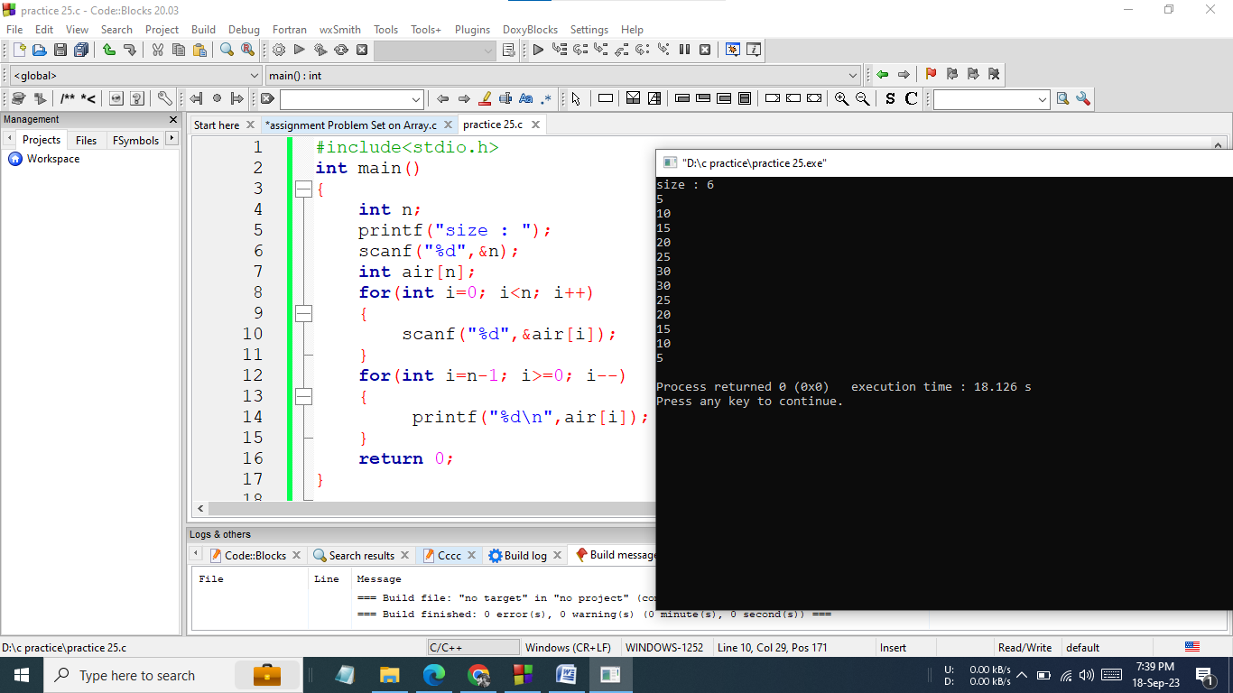

**Hand Written** **Code**:

**Problem No: 7**

**Problem Name:** Write a c program to take N user input in an array and print the sum of those N values.

**Source Code:**

#include<stdio.h>

int main()

{

int n,sum=0;

printf("Enter arry size : ");

scanf("%d",&n);

int air[n];

for(int i=0; i<n; i++)

{

scanf("%d",&air[i]);

}

for(int i=0; i<n; i++)

{

sum=sum+air[i];

}

printf("Sum = %d\n",sum);

return 0;

}

**Screenshot of output:**

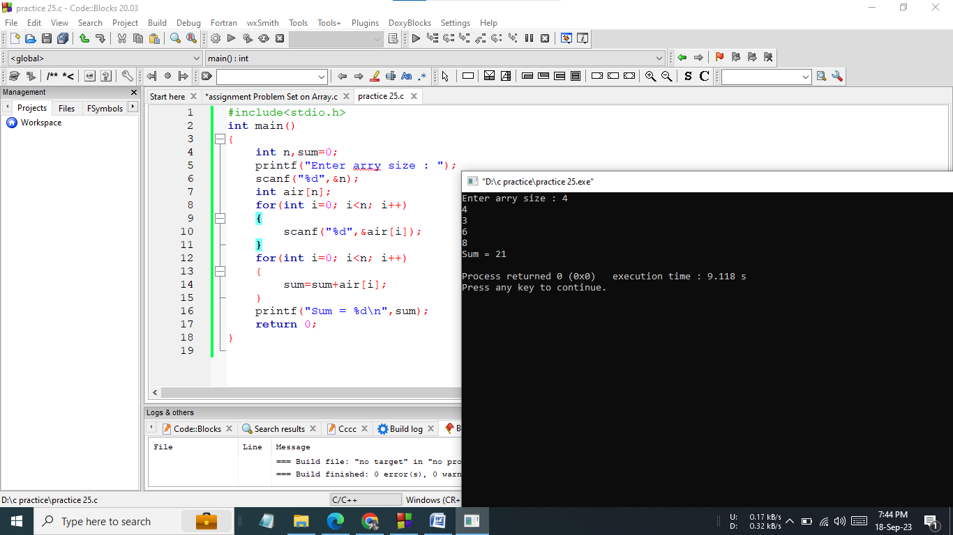

**Hand Written** **Code**:

**Problem No: 8**

**Problem Name:** Write a C program that would calculate the average of all the elements in an array array size and array input taken from the user .

**Source Code:**

#include <stdio.h>

int main()

{

int n,i;

float sum =0.0,avg;

printf("Enter array size : ");

scanf("%d",&n);

float air[n];

printf("Enter array elements : ");

for (i=0; i<n; ++i)

{

scanf("%f",&air[i]);

sum +=air[i];

}

avg = sum / n;

printf("Avg = %.2f",avg);

return 0;

}

**Screenshot of output:**

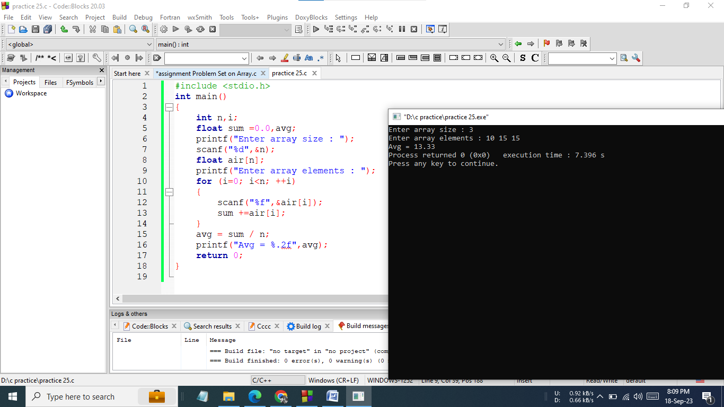

**Hand Written** **Code**

**Problem No: 9**

**Problem Name:** Write a C program to find the maximum value in an array

**Source Code:**

#include<stdio.h>

int main()

{

int n,max;

printf("Enter arry size : ");

scanf("%d",&n);

int a[n];

for(int i=0; i<n; i++)

{

scanf("%d",&a[i]);

}

max=a[0];

for(int i=0; i<n; i++)

{

if(a[i]>max)

{

max=a[i];

}

}

printf("Maximum:%d",max);

return 0;

}

**Screenshot of output:**

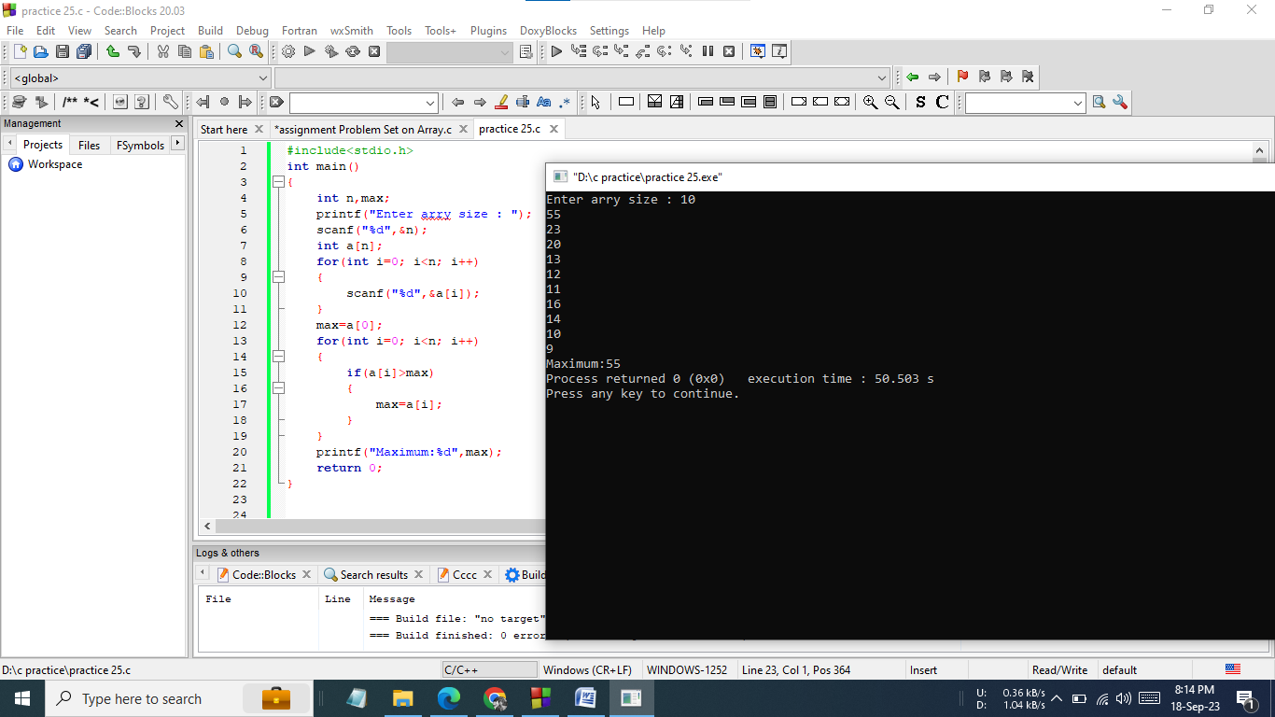

**Hand Written** **Code:**

**Problem No: 10**

**Problem Name:** Write a C program to find the minimum value in an array.

**Source Code:**

#include<stdio.h>

int main()

{

int n,min;

printf("Enter arry size : ");

scanf("%d",&n);

int a[n];

for(int i=0; i<n; i++)

{

scanf("%d",&a[i]);

}

min=a[0];

for(int i=0; i<n; i++)

{

if(a[i]<min)

{

min=a[i];

}

}

printf("Minimum:%d",min);

return 0;

}

**Screenshot of output:**

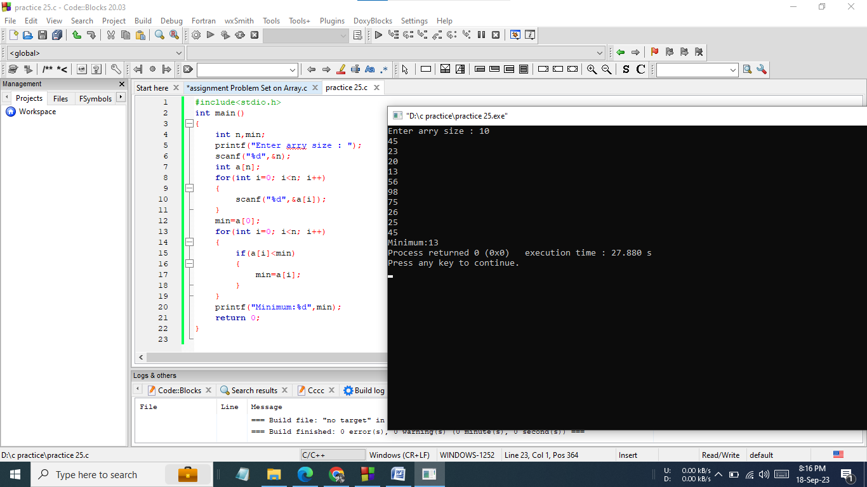

**Hand Written** **Code:**

**Problem No: 11**

**Problem Name:** Write a program in C to find the maximum and minimum element in an array.

**Source Code:**

#include<stdio.h>

int main()

{

int n,max,min;

printf("Enter arry size : ");

scanf("%d",&n);

int a[n];

for(int i=0; i<n; i++)

{

scanf("%d",&a[i]);

}

min=a[0];

max=a[0];

for(int i=0; i<n; i++)

{

if(a[i]>max)

max=a[i];

if(a[i]<min)

min=a[i];

}

printf("Maximum:%d\n",max);

printf("Minimum:%d\n",min);

return 0;

}

**Screenshot of output:**

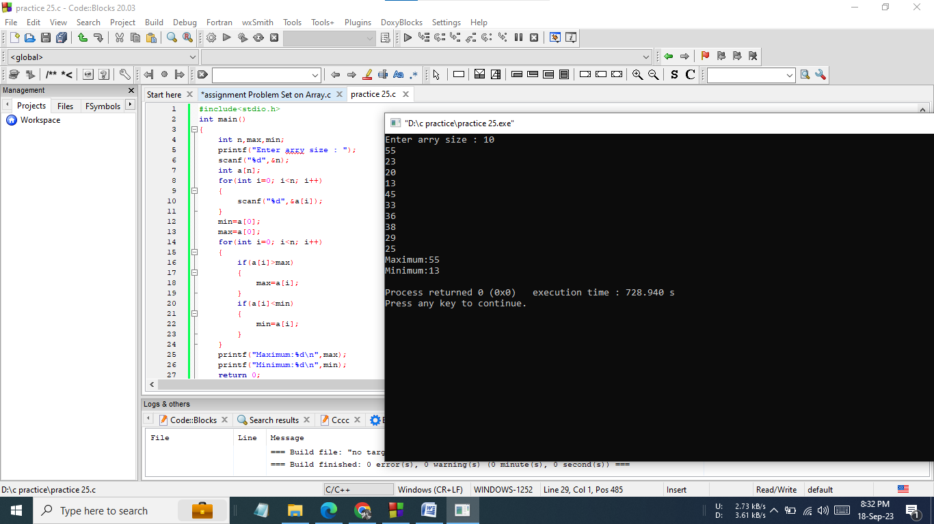

**Hand Written** **Code:**

**Problem No: 12**

**Problem Name:** Take a N size array and all array input from the user and also take an integer x and find whether the x exists in the array or not.If the x exists in array print YES otherwise print NO.

**Source Code:**

#include<stdio.h>

int main()

{

int n,i;

printf("Enter array size : ");

scanf("%d",&n);

int a[n],found,search;

printf("Enter arry elements : ");

for(i=0; i<n; i++)

{

scanf("%d",&a[i]);

}

printf("Finding value : ");

scanf("%d",&search);

found=0;

for(i=0; i<n; i++)

{

if(a[i]==search)

{

found=1;

break;

}

}

if(found==1)

{

printf("YES");

}

else

{

printf("NO");

}

return 0;

}

**Screenshot of output:**

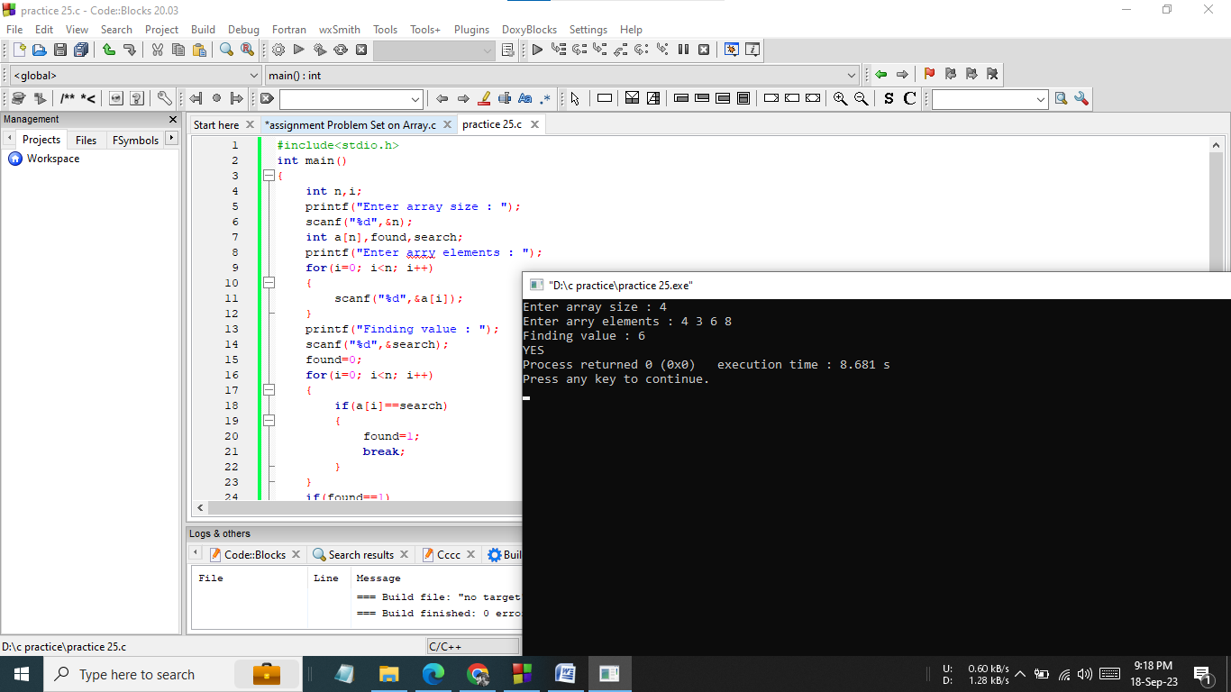

**Hand Written** **Code:**

**Problem No: 13**

**Problem Name:** Write a C program that would find the difference between the minimum and the maximum number in an array size and element taken from the user.

**Source Code:**

#include<stdio.h>

int main()

{

int max,min,n;

scanf("%d",&n);

printf("Enter arry elements : ");

int a[n];

for(int i=0; i<n; i++)

{

scanf("%d",&a[i]);

}

min=a[0];

max=a[0];

for(int i=0; i<n; i++)

{

if(a[i]>max)

max=a[i];

if(a[i]<min)

min=a[i];

}

int dif;

dif=max-min;

printf("Difference : %d\n",dif);

return 0;

}

**Screenshot of output:**

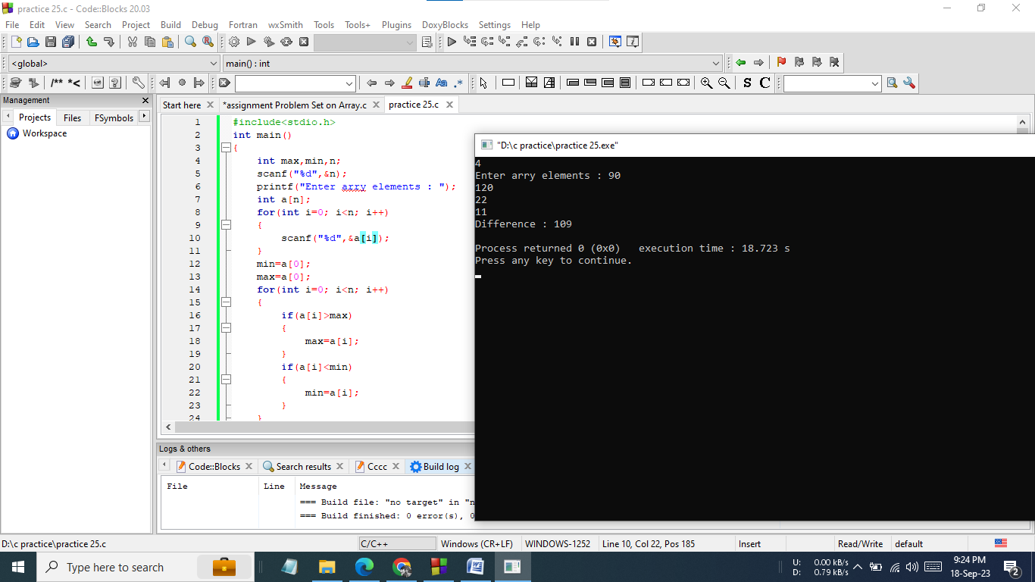

**Hand Written** **Code:**

**Problem No: 14**

**Problem Name:** Write a program in C to find the second largest element in an array

**Source Code:**

#include<stdio.h>

int main()

{

int n,max1,max2,temp=0;

printf("Enter array size : ");

scanf("%d",&n);

printf("Enter arry elements : ");

int a[n];

for(int i=0; i<n; i++)

{

scanf("%d",&a[i]);}

max1=a[0];

max2=a[1];

if(max2>max1)

{

temp=max1;

max1=max2;

max2=temp;

}

for(int i=2; i<n; i++)

{

if(a[i]>max1){

max2=max1;

max1=a[i];}

else if(a[i]>=max2)

max2=a[i];

printf("Second Max:%d\n",max2);

return 0;

}

**Screenshot of output:**

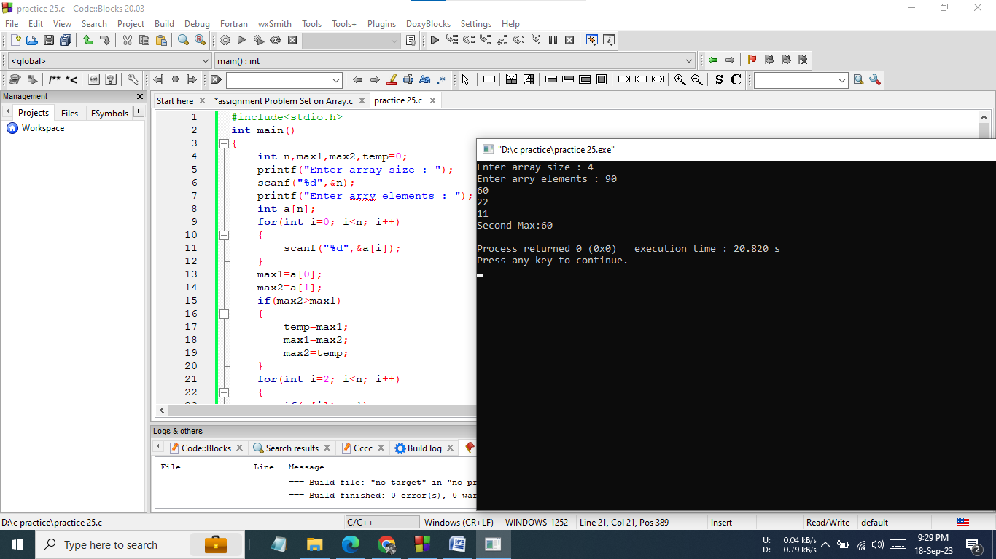

**Hand Written** **Code:**

**Problem No: 15**

**Problem Name:** Write a C program that would search for a particular number in an array.

**Source Code:**

#include<stdio.h>

int main()

{

int n,i,found,search;

scanf("%d",&n);

int a[n];

printf("Enter Arry Elements : ");

for(i=0; i<n; i++)

{

scanf("%d",&a[i]);

}

printf("Found at index : ");

scanf("%d",&search);

found=0;

for(i=0; i<n; i++)

{

if(a[i]==search){

found=1;

break;}

}

if(found==1)

printf("%d\n",i);

else

printf("Not found\n");

return 0;

}

**Screenshot of output:**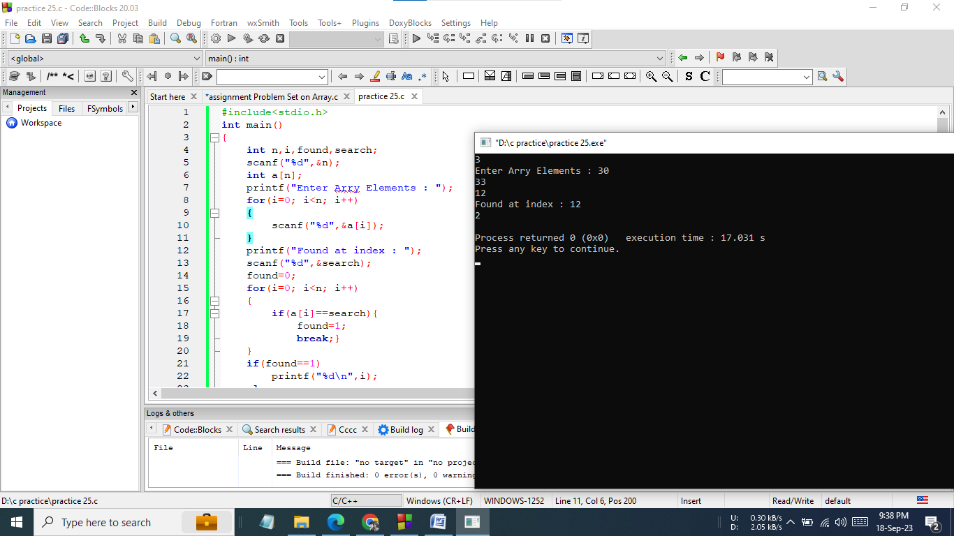

**Hand Written** **Code:**

**Problem No: 16**

**Problem Name:** Write a program in C to separate odd and even integers in separate arrays.

**Source Code:**

#include<stdio.h>

int main()

{

int n,i;

printf("Input array size : ");

scanf("%d",&n);

int a[n];

printf("Input elements in the array :\n");

for(i=0; i<n; i++)

{

scanf("%d",&a[i]);

}

printf("The Even elements are :\n");

for(int k=0; k<n; k++)

{

if(a[k]%2==0)

printf("%d ",a[k]);

}

printf("\n");

printf("The Odd elements are :\n");

for(int j=0; j<n; j++)

{

if(a[j]%2==1)

printf("%d ",a[j]);}

printf("\n");

return 0;

}

**Screenshot of output:**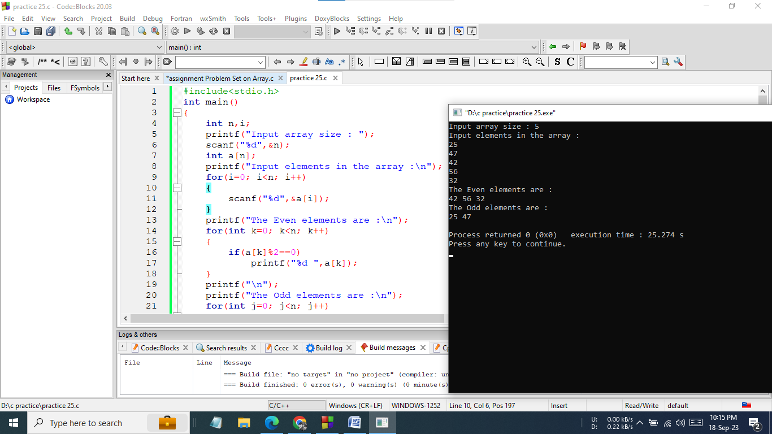

**Hand Written** **Code:**

**Problem No: 17**

**Problem Name:** Write a C program that would only print the sum of all the even numbers in an array.

**Source Code:**

#include<stdio.h>

int main()

{

int n,i,sum=0;

scanf("%d",&n);

int a[n];

printf("Enter array elements : ");

for(i=0; i<n; i++)

{

scanf("%d",&a[i]);

}

for(int k=0; k<n; k++)

{

if(a[k]%2==0)

sum=sum+a[k];

}

printf("Sum of Even Numbers = %d\n",sum);

return 0;

}

**Screenshot of output:**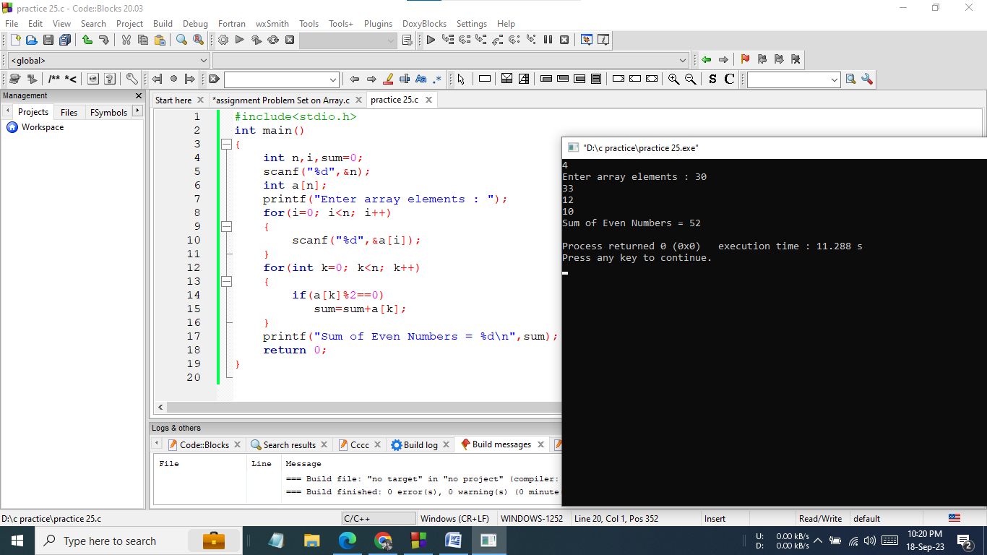

**Hand Written** **Code:**

**Problem No: 18**

**Problem Name:** Write a C program that would count the even numbers in an array.

**Source Code:**

#include<stdio.h>

int main()

{

int i,n,even=0;

scanf("%d",&n);

int a[n];

printf("Enter Array Elements : ");

for(i=0; i<n; i++)

{

scanf("%d",&a[i]);

}

for(int k=0; k<n; k++)

{

if(a[k]%2==0)

even++;

}

printf("No. Even Numbers: %d\n",even);

return 0;

}

**Screenshot of output:**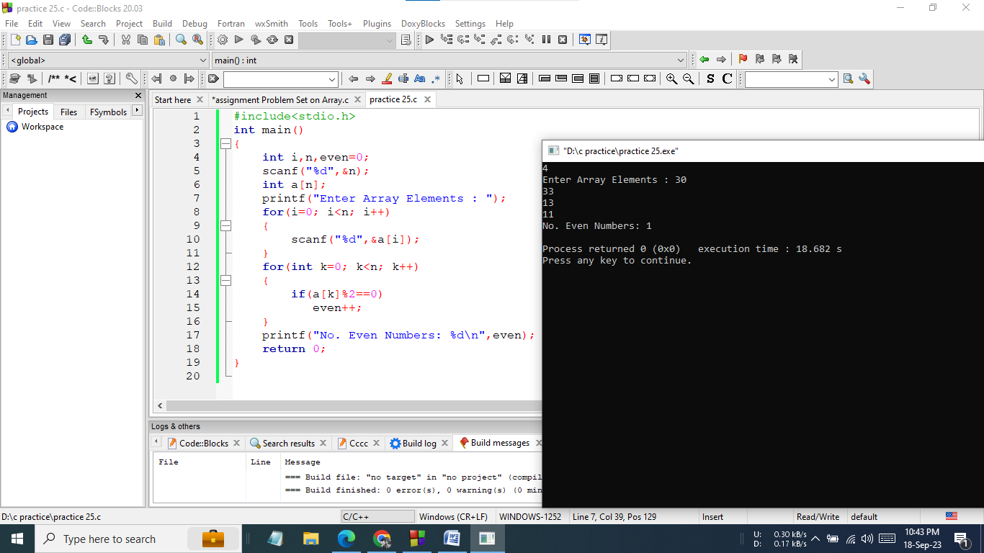

**Hand Written** **Code:**

**Problem No: 19**

**Problem Name:** Write a program in C to print the duplicate elements in an array.

**Source Code:**

#include<stdio.h>

int main()

{

int n,i,j,k;

scanf("%d",&n);

int a[n],b[n];

printf("Enter array elements :\n");

for(i=0; i<n; i++)

{

scanf("%d",&a[i]);

}

printf("Duplicate :\n");

for(i=0; i<n; i++)

{

for(j=i+1; j<n-1; j++)

{

if(a[i]==a[j])

printf("%d\n",a[j]);

}

}

return 0;

}

**Screenshot of output:**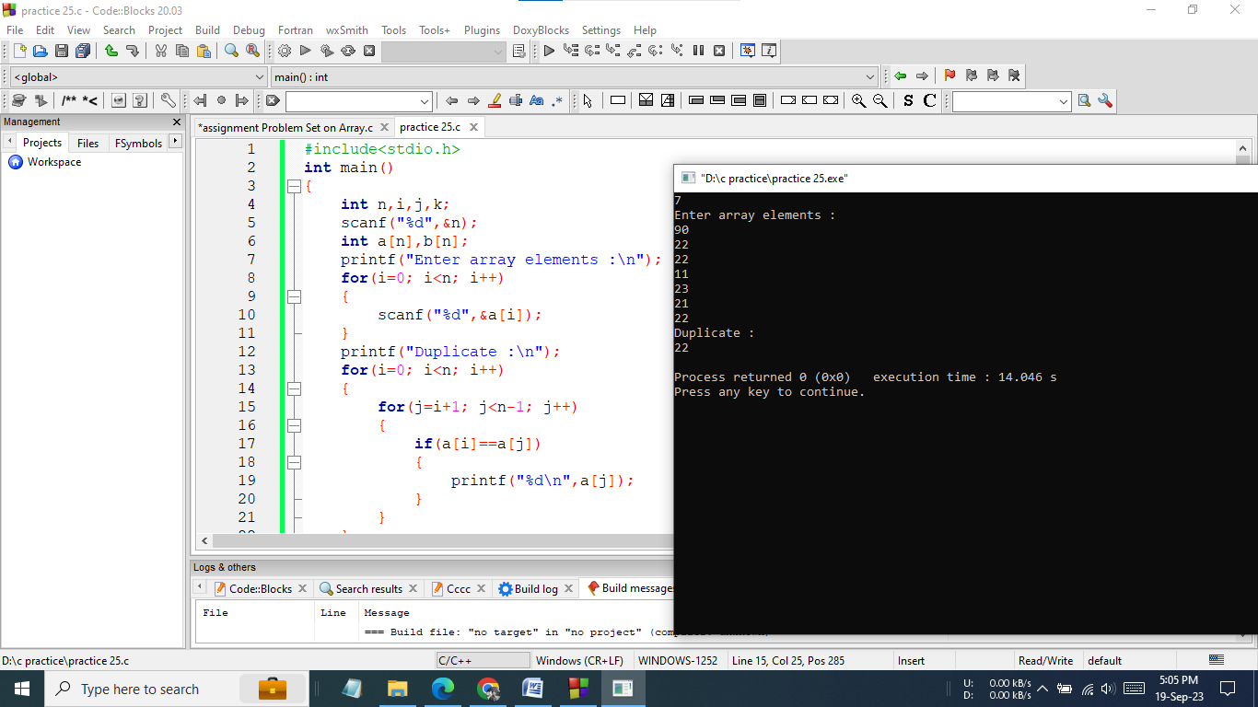

**Hand Written** **Code:**

**Problem No: 20**

**Problem Name:** Write a program in C to print the duplicate elements in an array.

**Source Code:**

#include <stdio.h>

int main()

{

int n,i,j,count;

scanf("%d",&n);

int arr[n],freq[100];

printf("Enter arry elements:\n");

for(i=0; i<5; i++){

scanf("%d", &arr[i]);

freq[i] = -100;

}

for(i=0; i<5; i++){

count = 1;

for(j=i+1; j<5; j++)

{

if(arr[i] == arr[j])

{

count++;

freq[j] = 0;

}

}

if(freq[i] != 0)

freq[i] = count;

}

printf("\nUnique elements :\n");

for(i=0; i<5; i++){

if(freq[i]==1)

printf("%d\n", arr[i]);}

return 0;

}

**Screenshot of output:**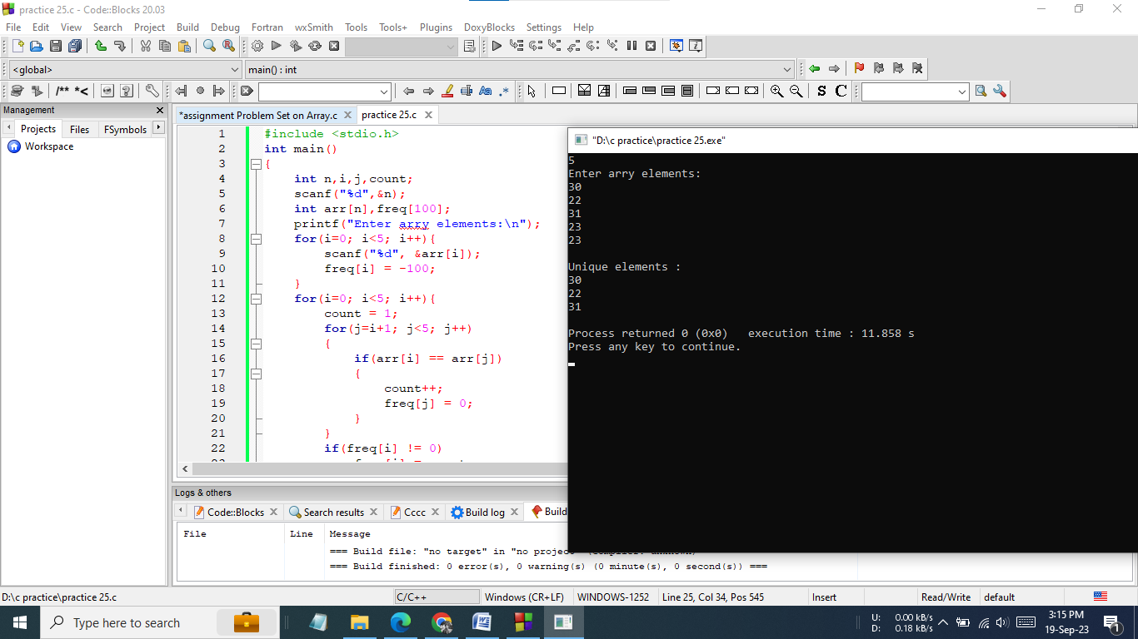

**Hand Written** **Code:**

**Problem No: 21**

**Problem Name:** Take a N size array and array element taken from user.Write a program in C to copy the elements of one array into another array.

**Source Code:**

#include<stdio.h>

int main()

{

int n,i;

printf("Array size : ");

scanf("%d",&n);

int a[n],b[n];

for(i=0; i<n; i++)

{

scanf("%d",&a[i]);

}

for(i=0; i<n; i++)

{

b[i]=a[i];}

printf("The elements stored in the first array are : ");

for(i=0; i<n; i++)

{

printf("%d ",a[i]);}

printf("\nThe elements copied into the second array are : ");

for(i=0; i<n; i++)

{

printf("%d ",b[i]);}

return 0;

}

**Screenshot of output:**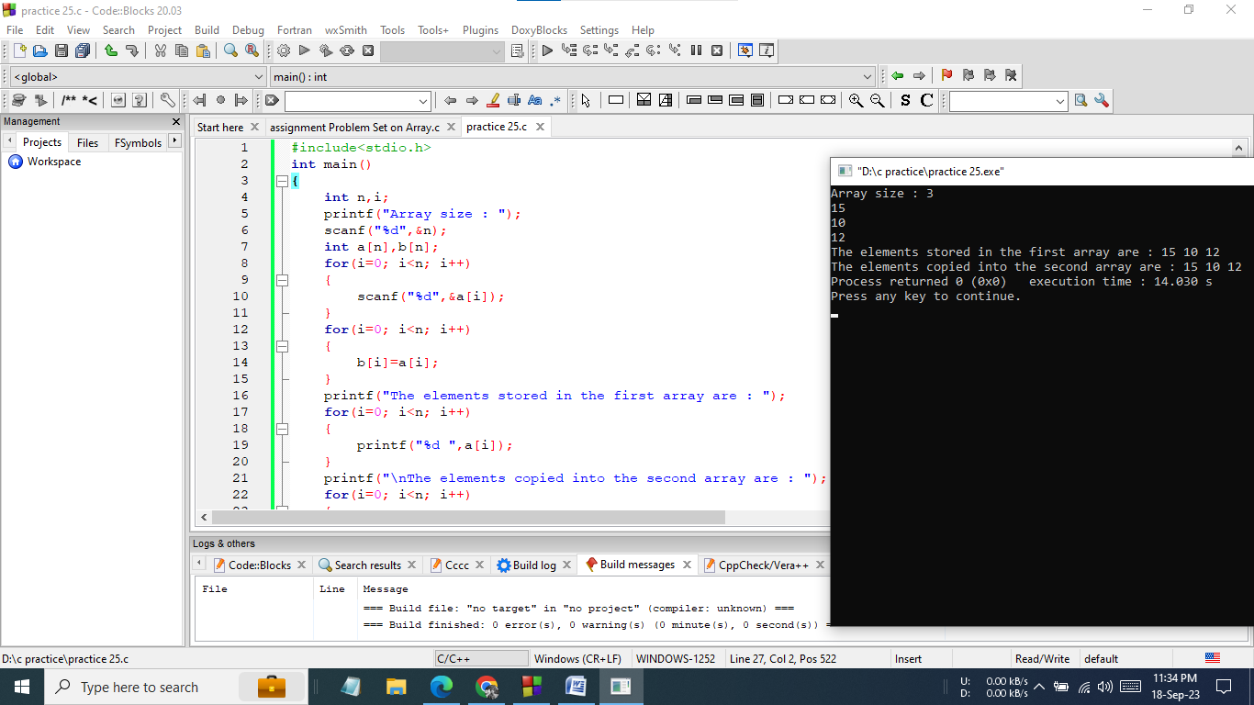

**Hand Written** **Code:**

**Problem No: 22**

**Problem Name:** Write a program in C to sort elements of an array in ascending order.

**Source Code:**

#include<stdio.h>

int main()

{

int n,i,j,temp;

scanf("%d",&n);

int a[n];

for(i=0; i<n; i++)

{

scanf("%d",&a[i]);

}

for(i=0; i<n; i++)

{

for(j=i+1; j<n; j++)

{

if(a[i]>a[j])

{

temp=a[i];

a[i]=a[j];

a[j]=temp;

}

}

}

for(i=0; i<n; i++)

printf("%d ",a[i]);

return 0;

}

**Screenshot of output:**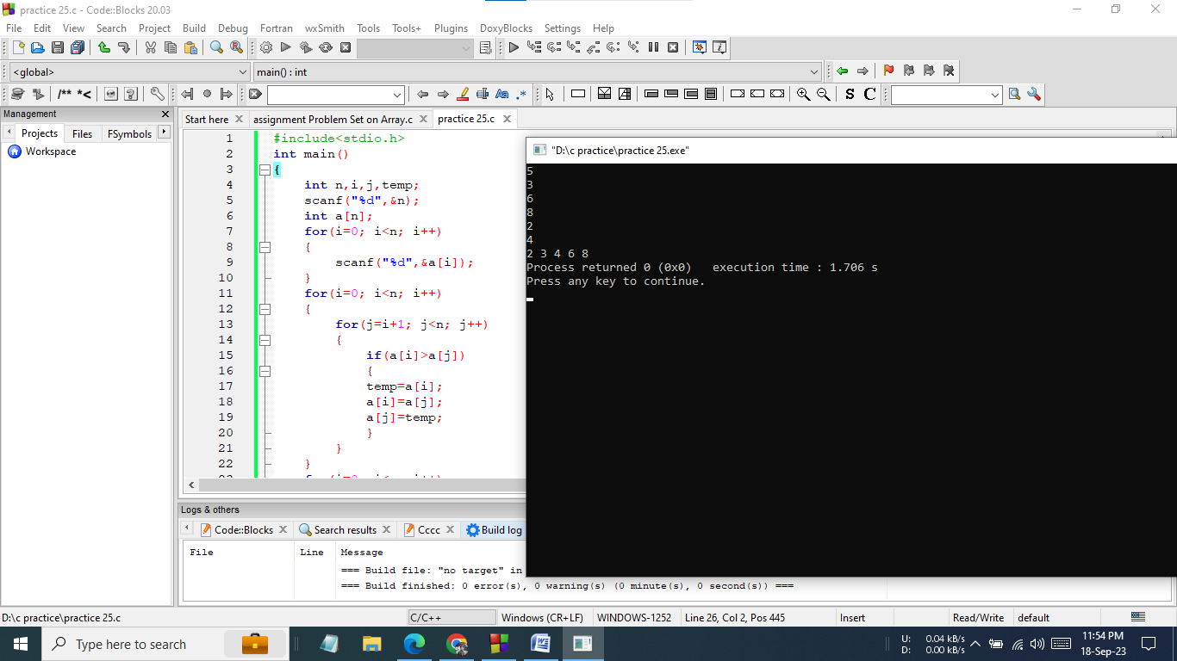

**Hand Written** **Code:**

**Problem No: 23**

**Problem Name:** Write a program in C to sort the elements of the array in descending order.

**Source Code:**

#include<stdio.h>

int main()

{

int n,i,j,temp;

scanf("%d",&n);

int a[n];

for(i=0; i<n; i++)

{

scanf("%d",&a[i]);}

for(i=0; i<n; i++)

{

for(j=i+1; j<n; j++)

{

if(a[i]>a[j])

{

temp=a[i];

a[i]=a[j];

a[j]=temp;

}

}

}

for(i=n-1; i>=0; i--)

printf("%d ",a[i]);

return 0;

}

**Screenshot of output:**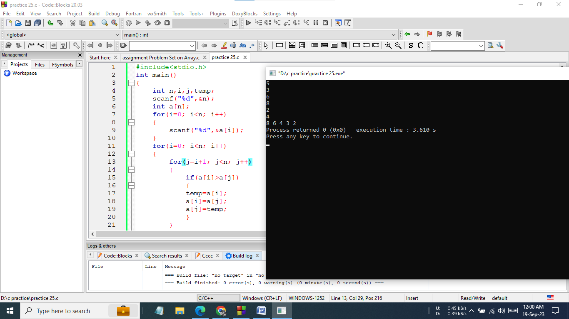

**Hand Written** **Code:**

**Problem No: 24**

**Problem Name:** Write a program in C to find the second largest element in an array..

**Source Code:**

#include<stdio.h>

int main()

{

int max1,max2,temp=0,n;

scanf("%d",&n);

int a[n];

for(int i=0; i<n; i++)

{

scanf("%d",&a[i]);

}

max1=a[0];

max2=a[1];

if(max2>max1)

{

temp=max1;

max1=max2;

max2=temp;

}

for(int i=2; i<n; i++)

{

if(a[i]>max1)

{

max2=max1;

max1=a[i];

}

else if(a[i]>=max2)

{

max2=a[i];

}

}

printf("%d\n",max2);

return 0;

}

**Screenshot of output:**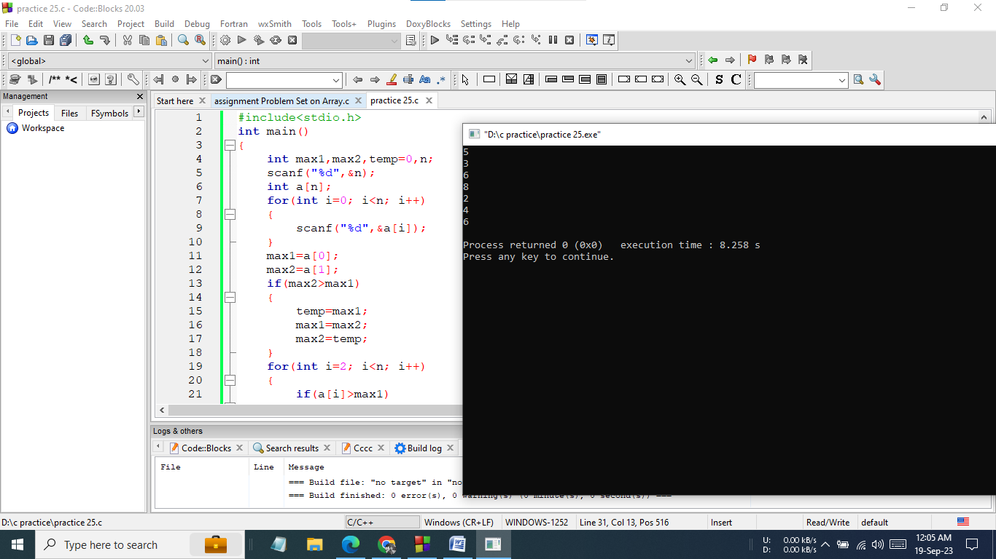

**Hand Written** **Code:**

**Problem No: 25**

**Problem Name:** Write a program in C to find the second smallest element in an array.

**Source Code:**

#include<stdio.h>

int main()

{

int min1,min2,temp=0,n;

scanf("%d",&n);

int a[n];

for(int i=0; i<n; i++)

{

scanf("%d",&a[i]);

}

min1=a[0];

min2=a[1];

if(min2<min1)

{

temp=min1;

min1=min2;

min2=temp;

}

for(int i=2; i<n; i++)

{

if(a[i]<min1)

{

min2=min1;

min1=a[i];

}

else if(a[i]<=min2)

{

min2=a[i];

}

}

printf("%d\n",min2);

return 0;

}

**Screenshot of output:**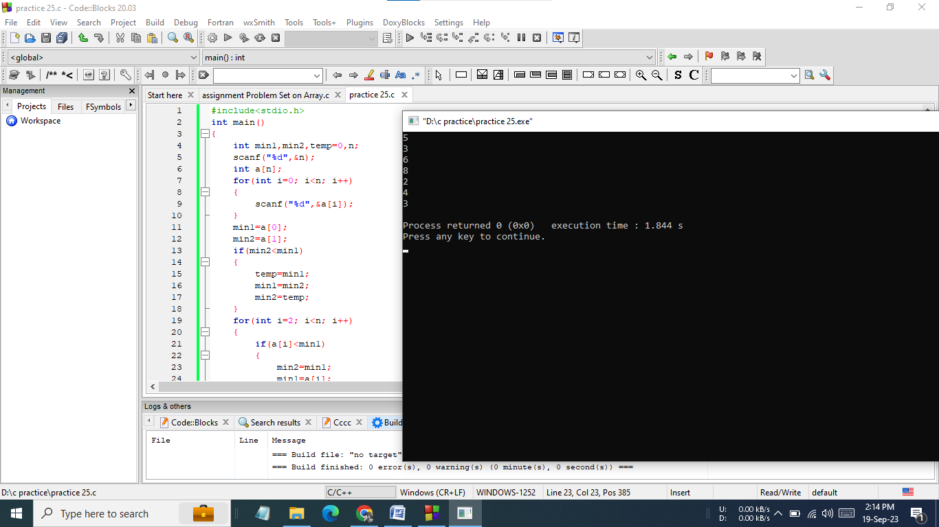

**Hand Written** **Code:**

**Problem No: 26**

**Problem Name:** Write a program in C to merge two arrays of the same size.

**Source Code:**

#include<stdio.h>

int main()

{

int n1,n2,i;

printf("Array size : ");

scanf("%d",&n1);

int a1[n1];

for(i=0; i<n1; i++)

{

scanf("%d",&a1[i]);

}

printf("Array size : ");

scanf("%d",&n2);

int a2[n2];

for(i=0; i<n2; i++)

{

scanf("%d",&a2[i]);}

int n3;

n3=n1+n2;

int a3[100];

int temp=0;

for(i=0; i<n1; i++)

a3[i]=a1[i];

for(i=0; i<n2; i++)

a3[i+n1]=a2[i];

for(i=0; i<n3; i++)

printf("%d ",a3[i]);

return 0;

}

**Screenshot of output:**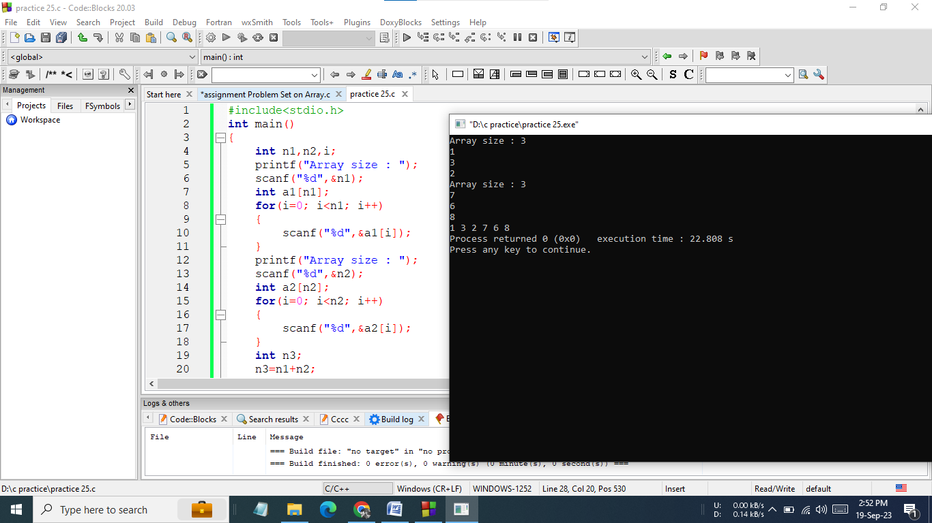

**Hand Written** **Code:**

**Problem No: 27**

**Problem Name:** Write a program in C to count the frequency of each element of an array.

**Source Code:**

#include <stdio.h>

int main()

{

int n,i,j,count;

scanf("%d",&n);

int a[n],f[100];

for(i=0; i<n; i++)

{

scanf("%d",&a[i]);

f[i]=-100;

}

for (i=0; i<n; i++)

{

count=1;

for (j =i+1; j<n; j++)

{

if (a[i]==a[j])

{

count++;

f[j]=0;

}

}

if (f[i]!=0)

f[i]=count;

}

for (i=0; i<n; i++)

{

if (f[i]!=0)

printf("%d occurs %d times\n",a[i],f[i]);}

return 0;

}

**Screenshot of output:**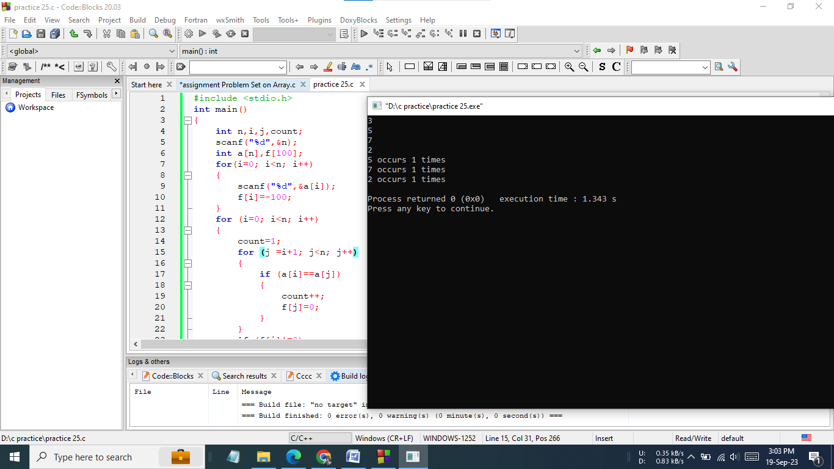

**Hand Written** **Code:**